Software Requirement Specification

For
Project
<CCBFS>

Version 1.0 approved
Prepared and Developed by Team A-1
For: Country Club
As of 8 August 2017
Table of Contents
- Introduction
  - Purpose
  - Intended Audience
  - Project Scope
  - References
- Overall Description
  - Product Features
  - User Classes and Characteristics
  - Operating Environment
  - Design and Implementation Constraint
  - User Documentation
  - Assumptions and Dependencies
- System Features
- Additional Appendixes
  - Appendix A
  - Appendix B
  - Appendix C

- Introduction
  - Purpose
The purpose of this software product is to allow club members to make bookings online. It also helps the manager to manage the country club in a more organized and orderly manner.
The Purpose of this document is to entail all the details that the user is left unambiguous about what is and isn’t being developed. A common agreement.
  - Intended Audience and Reading Suggestions
This is intended for country club members and the manager who will be using our software product to reduce communication overhead. This allows our clients to have a shorter and pleasant booking experience. This document intends to inform the users of the purpose and scope of this particular ‘CCFBS’ software product.
  - Project Scope
The scope of this product is to enable country club members to view the availability and prices of the facilities as well as making and changing their bookings. It also allows members to check their membership tier and the discounts entitled to them.
They can also update their personal particulars and store their booking preferences as well as upgrading their membership.
It also allows the club manager to create, delete, amend and update the club’s facilities for booking and set the various charging rates.
The software also will be able to generate a report which graphically displays the popularity of facilities and the frequency of a facility is in used and in popularity .

- Overall Description
2.1 Product Perspective
This is a new, self-contained product. The system will be in 3 main parts, the Application/Program(main executable) , the User Database , and the Booking Database.
The program is where any User interactions will take place. Any Interactions with User Database and Booking Database shall be covered by the program.
User Database will contain encrypted personal information and User data related to the program shall be kept here.
Booking Database will contain encrypted Booking information and relevant user data shall be kept here.
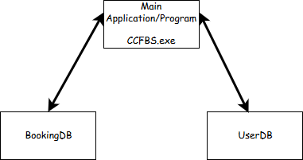
Component diagram of CCFBS

2.2 Product Features
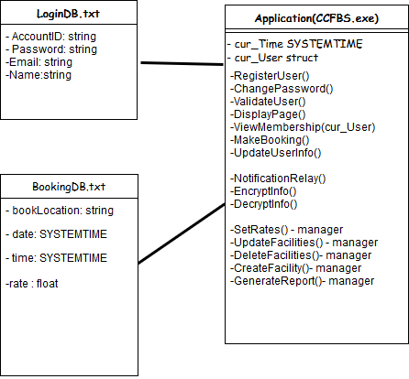

2.3 User Classes and Characteristics
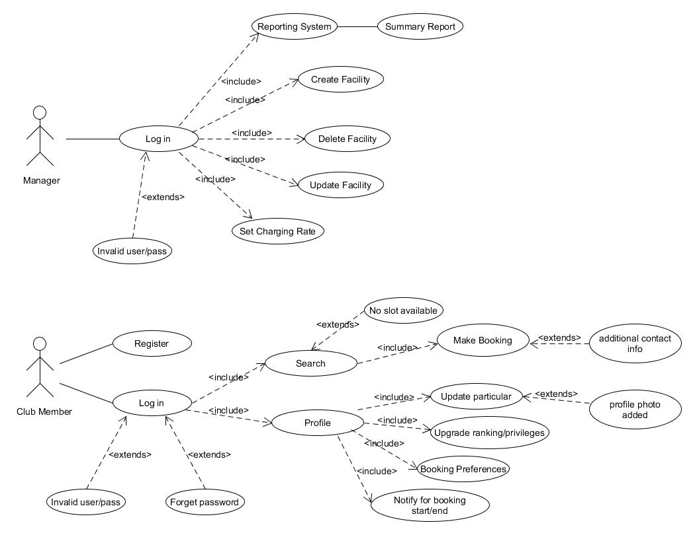
General Use Case 1.0 Typical operations of what a member and what a manager can do.
-Users of the system should be able to register if they have not been registered in the system.
-Users should be able to authenticate themselves via their saved entries in UserDB.
Once validated, Users can update and view their profile information or search for facilities to book within their privileges and book within available bookings left.

Managers would be able to view current booking trends within the facilities and change any existing reservations, delete and create new facilities as well as change the current rates.

2.4 Operating Environment
To Be written in C++.
Rationale: Extensibility and maintainability

To be run using Windows Operating System.
Rationale: Best supported and user-friendliness.

2.5 Design and Implementation Constraints
The software product will be written in C++.

2.6 Assumptions and Dependencies
The software product will run on Windows.

- System Features

